**Key Factors Influencing Excessive Absenteeism: Age, Reasons for Absence, and Transportation Expenses with Children**

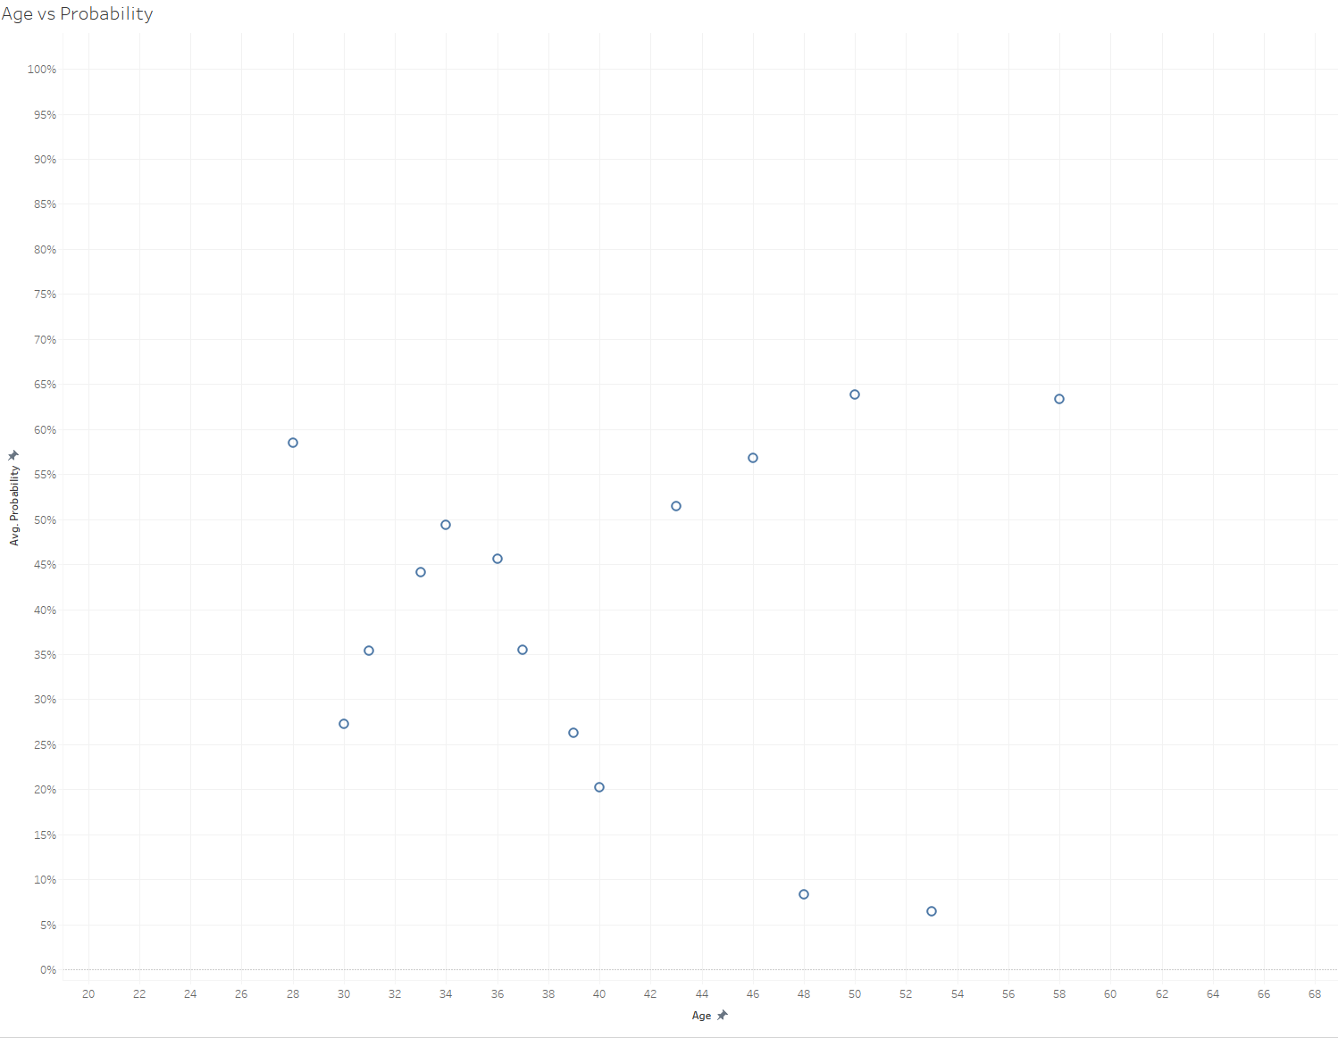

1. Age and Excessive Absenteeism:

* Younger individuals, particularly those around 30-34 years old, show lower probabilities of excessive absenteeism (around 30-40%).
* The probability increases significantly for individuals aged 50+, suggesting age might be a strong determinant of excessive absenteeism.

1. Age Groups and Noticeable Probabilities:

* Individuals in their 40s display a mix of moderate and high probabilities (ranging from 40% to 60%).
* For younger age groups (<30), absenteeism is generally below 30%, reflecting more consistent attendance.

1. Potential Influence of Age:

* Health-related factors: Older employees may experience more health issues, leading to increased absenteeism.
* Lifestyle or work-life balance: employees in the 30-40 age range might balance work better, reducing excessive absenteeism.

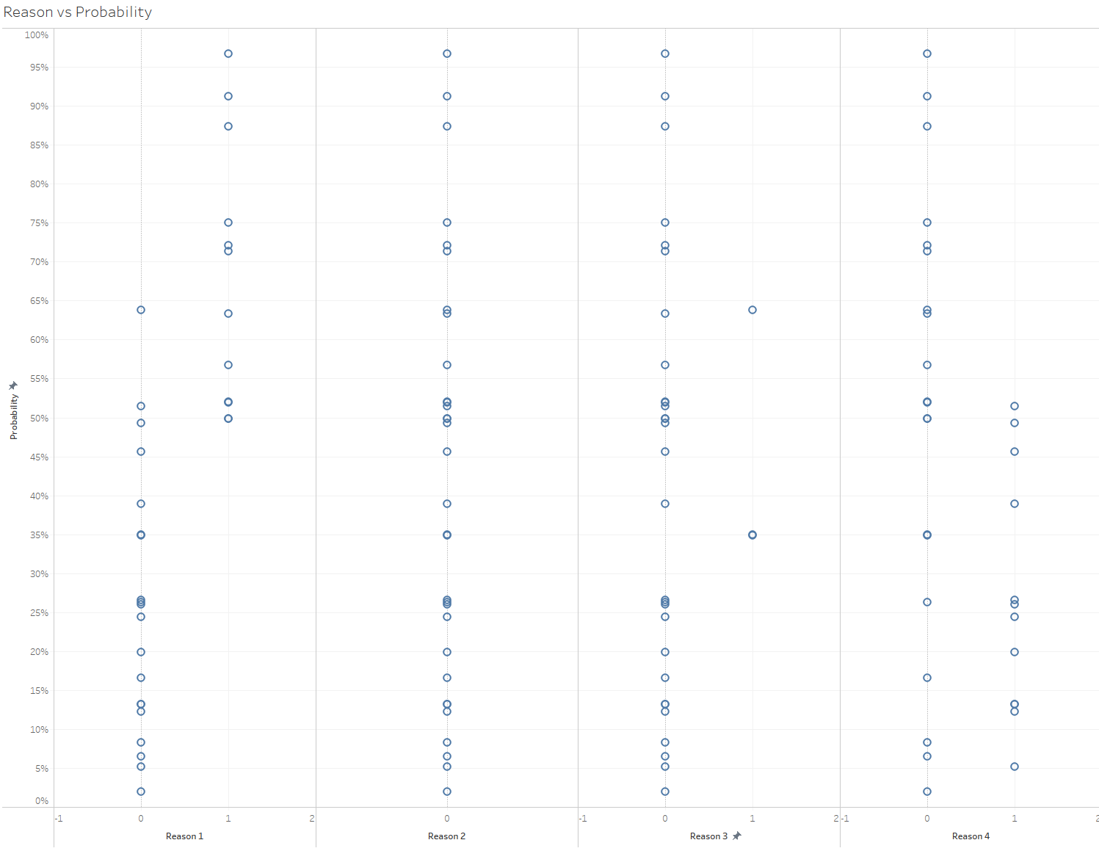

1. Reason 1 (Various Diseases):

* Observations:
* For individuals with Reason 1, the probability of being excessively absent (more than 3 hours) is consistently above 50%.
* This indicates that serious medical issues are strongly correlated with excessive absenteeism.
* Analysis:
* The nature of ‘various diseases’ suggests these are likely chronic or severe conditions that necessitate prolonged recovery or frequent medical attention.
* This trend reinforces the need for workplace support, such as flexible sick leave policies or health benefit programs, to accommodate such employees.

1. Reason 2 (Pregnancy and Giving Birth):

* Observations:
* Interestingly, there are no observations (40 records) where this reason has been cited for excessive absenteeism.
* Analysis:
* This might suggest either of only 40 observations, or a reflection of workforce demographics (e.g., fewer employees in roles prone to this reason).
* If relevant, it might be worth investigating whether this category applies to this workforce or if requires re-evaluation for completeness.

1. Reason 3 (Poisoning):

* Observations:
* The probabilities are scattered, with some below 50% and others above 50%, forming a widely distributed pattern.
* Very few observations of people who had specified this reason for excessive absence.
* Analysis:
* The inconsistent distribution suggests that poisoning is not a strong predictor of excessive absenteeism in this dataset. This could be due to variability in the severity of poisoning cases or a limited number of relevant incidents in the dataset.
* The lack of a clear trend makes it difficult to draw actionable insights or expectations from this category.

1. Reason 4 (Light Diseases):

* Observations:
* Probabilities are consistently below 50%, suggesting that light diseases are less likely to result in excessive absenteeism.
* Analysis:
* ‘Light diseases’ don’t severely impact the employee’s ability to work.
* This aligns with the expectation that such reasons don’t necessitate prolonged absences, supporting a pattern of lower absenteeism.

General Insights:

* Key Distinctions:
* Reason 1 stands out as the primary cause of excessive absenteeism due to its strong correlation with probabilities exceeding 50%.
* Reason 4, conversely, exhibits minimal impact, reflecting the lesser severity of ailments.
* Uncertainty in Reason 3:
* The scattered probabilities suggest further investigation or a larger dataset maybe required to clarify its role in excessive absenteeism.
* Workforce Implications:
* The absence of observations for Reason 2 might require exploring workforce demographics or organizational context to confirm if this category is applicable.

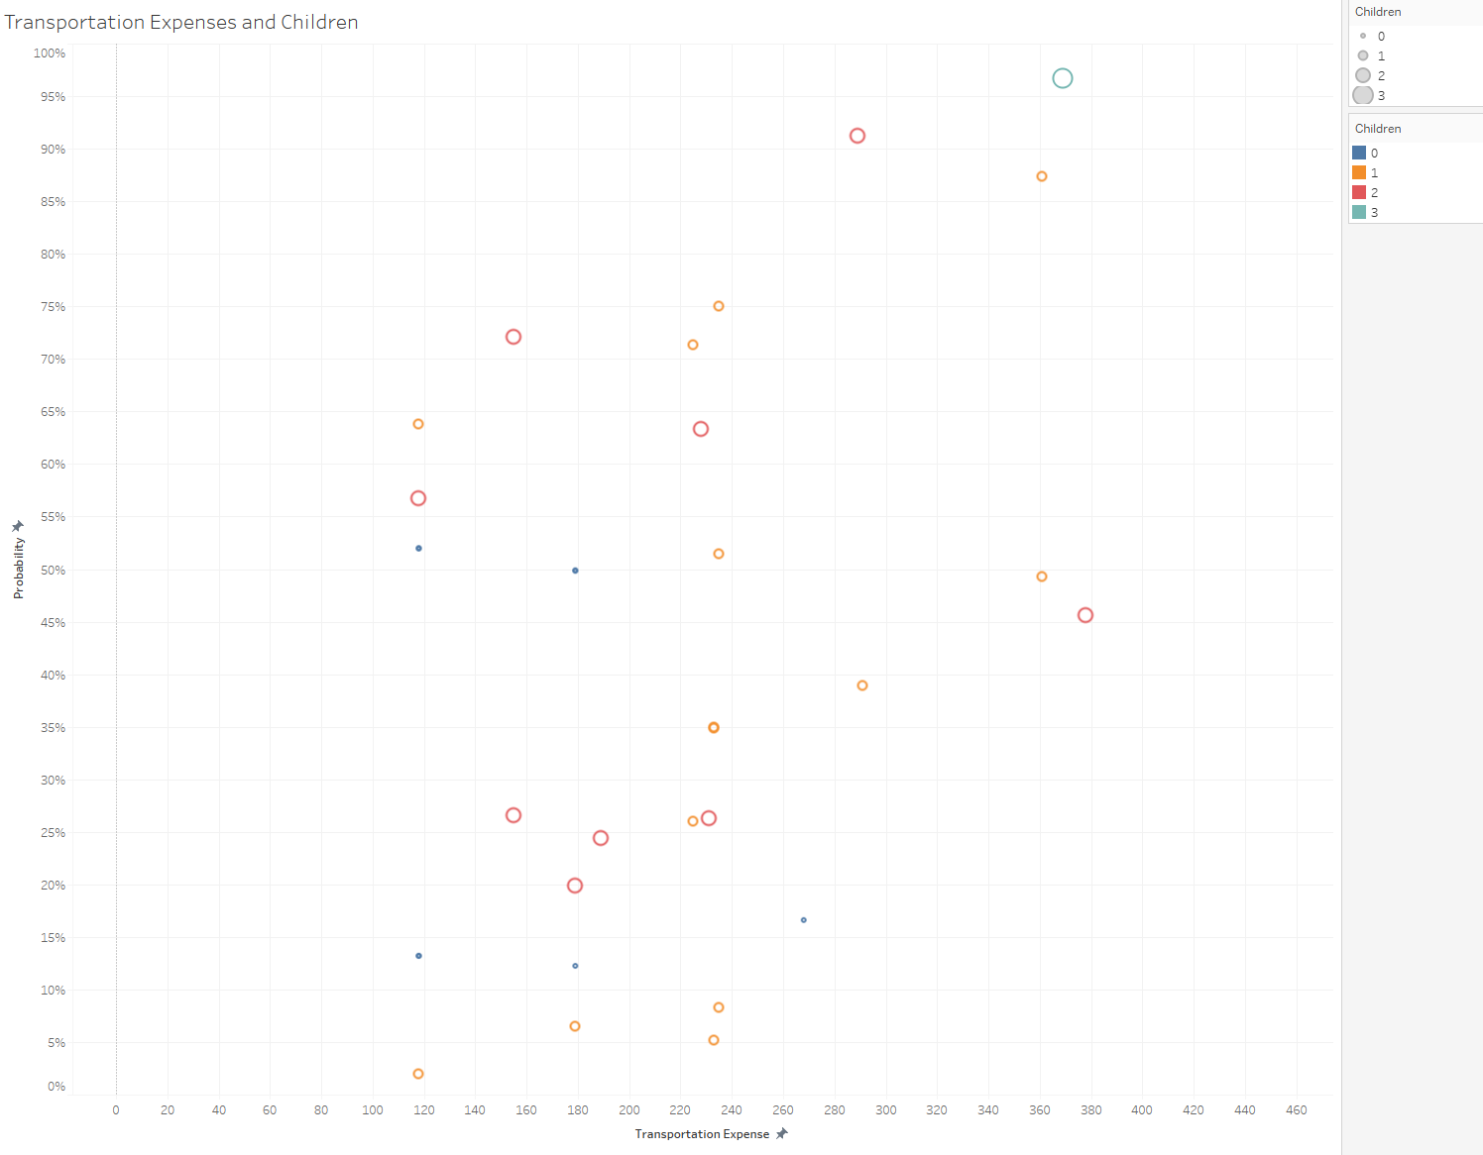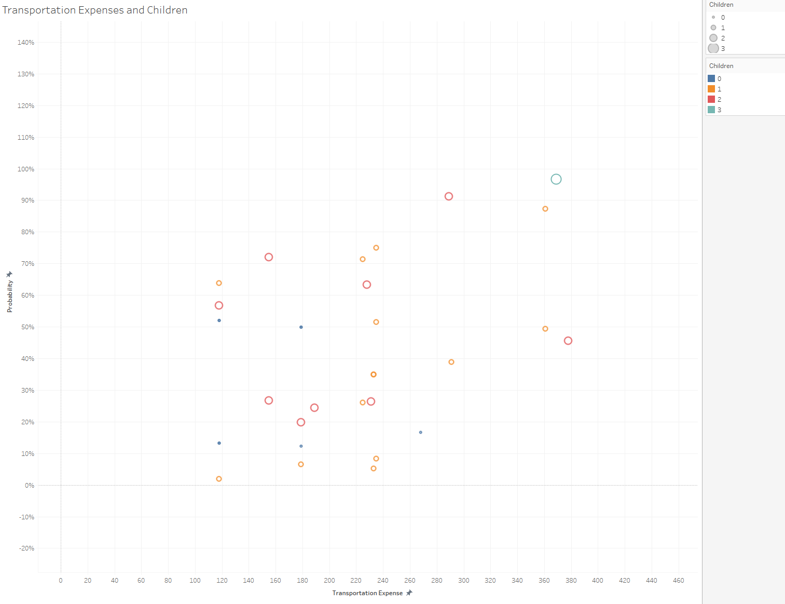

1. General Insights on Correlation:

* Observations: There is a potential correlation between transportation expenses and excessive absenteeism, likely stronger with more data.
* Analysis: Higher expenses may indicate greater commuting distances, leading to increased absenteeism probabilities.

1. Individuals with No Children:

* Observations: Low absenteeism probabilities and lower transportation expenses, with no significant outliers.
* Analysis: Proximity to work and fewer responsibilities likely contribute to reduced absenteeism

1. Individuals with 1 Child:

* Observations: Probabilities vary, with most clustered around $220-$240 in transportation expenses.
* Analysis: Transportation costs are predictable, but absenteeism is influenced by additional factors like childcare responsibilities.

1. Individuals with 2 Child:

* Observations: Similar trends to 1-child group, with 2 outliers spending above $240.
* Analysis: Higher expenses may reflect longer commutes or access to better schools, increasing absenteeism risk for some.

1. Individuals with 3 Child:

* Observations: Only 1 observation, insufficient for meaningful analysis.
* Analysis: Limited data restricts conclusions about larger families.

Concluding Insights:

* Transportation Expenses: Higher costs correlate with greater absenteeism, likely due to longer commutes.
* Family size: Employees with no children have lower absenteeism, while those with one or two children show moderate impacts, influenced by transportation costs.

Overall Conclusion:

The analysis identifies three primary factors contributing to excessive absenteeism: age, reasons for absence, and transportation expenses in combination with family responsibilities.

* Serious health conditions are the most significant driver of excessive absenteeism, while lighter illness show lower impacts
* Older individuals tend to have a higher probability of being excessively absent, possibly due to age-related health or personal factors.
* Higher transportation costs, especially among employees with one or two children, indicate commuting challenges contributing to excessive absenteeism.

Addressing these factors with targeted interventions, such as health support programs, remote work policies, or subsidized commuting options, could reduce excessive absenteeism and improve workforce productivity.